Curriculum Vitae Mobile:
Dr.-Ing, Ömer Sahin Ganiyusufoglu China: +86/15140015426
Germ: +49/15778921954

Stauffenbergstr.1
73760 Ostfildern

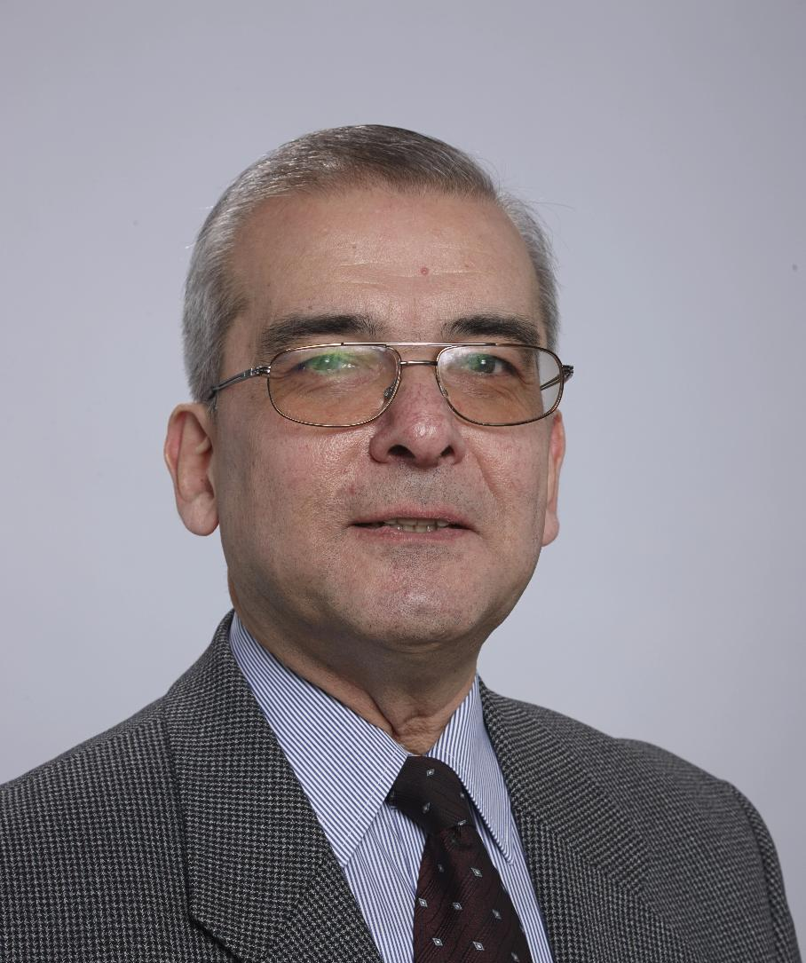

24. May 1954 born in Istanbul/Turkey
married since 1979, one son – medical doctor,
all German Citizens / Resident in Germany and in China

1965 – 1973 Deutsche Schule Istanbul/Turkey
Achievement of German Bachelor

1974 – 1979 Technical University Berlin
Study of Machine Tools and Manufacturing Technology,
Majors: Machine Tools, Production Technology

1980 – 1985 Scientific assistant at Institute for Machine Tools and
Manufacturing Technology (IWF/TU Berlin) and Fraunhofer
Institute for Production Technology and Design (IPK – Berlin),
Both headed by Prof. Dr.-Ing. Günter Spur

Special areas: Penetration of CNC technology in SMEs,
Automation of machine tools by robots,
Industrial applications of robots, CIM

    - Graduation to Dr.-Ing.
Title of thesis: Economic use of Flexible Manufacturing Cells on the example of Turning Cells. A thesis based on an industrial project.

1985 – 1989 Traub Drehmaschinen GmbH, later Traub AG
Department Manager for Systems Technology, customer
oriented turn key systems including robot applications and
software periphery, CIM solutions

Entire responsibility for sales, engineering, production and after
sales services reporting to technical board member

1990 – 1994 General Manager for Technics at Yamazaki Mazak GmbH
Japanese family owned machine tool manufacturer

1994 – 2005 Managing Director of Yamazaki Mazak GmbH,
Responsible for sales, marketing, technical sales,
engineering, after sales services, finance in Germany,
Switzerland, Austria and Eastern Europe /
Cooperation with Sales & Engineering HQ Japan about new
developments and strategies

2006 – 2010 General Manager of Index Dalian Machine Tool Ltd.
Joint venture between Index-Werke Esslingen (65% share) and
Dalian Machine Tool Group (35% share)
Resident in Dalian/China

Responsible for production, sales, marketing, technical sales,
engineering, after sales services and finance

Establishment of own and dealers’ sales network in China,
production expansion, establishment of suppliers’ network,
market research

2011 – present Shenyang Machine Tool Group Ltd., Co. (SYMG)
- Consultant to Chairman –
Largest state owned machine tool manufacturer
Resident in Shenyang
Support of Chairman and Top Management in all matters of
machine tool business, especially globalization, international
industrial and acamedic cooperations, transformation from state
owned enterprise to a global player

Others: SYMG since 2014 Corporate Member of CIRP
- Representative of SYMG at CIRP –

Since 2017 Chairman of Corporate Members Advisory Group CMAG within CIRP

Privately: Since 1977: Member of VDI - German Engineers’
Association

Since 1980: Member of REFA - German Association for Production Systematic

Since 1988: Member of Lions-Club in Esslingen/Germany

2008: Award of the City of Dalian/China

2012: Rose Prize of the City of Shenyang/China

2012: Guest Professor of Tongji University/Mechanical Faculty

2014: Friendship Award of Liaoning Province of China
Highest Award of the province for a foreigner

2018: Friendship Award of Chinese Central Government
Highest Award of China for a foreigner

Dr. Ömer Sahin Ganiyusufoglu

e-Mail: o.ganiyusufoglu@gmx.de
o.ganiyusufoglu@gmail.com

